**HOA NEWSLETTER** December 2021 issue



Welcome to the traditional opening of the Winter Season at the Beaver Creek Lodge. Even though Beaver Creek Mountain was off to a late start they have been successful in getting enough snow for two “Birds of Prey” two that the FIS officials have sanctioned the races, we will be hosting two Men’s Downhill and two Super G events on December 3rd to 5th.

We are excited to start the Winter Season with our brand-new staff! All of us here are appreciative of our owners and excited as we take the Beaver Creek Lodge to the next level. Thank you and Happy Holidays!

A WARM WELCOME

PAUL JEPPSON – GENERAL MANAGER

MEET THE NEW TEAM

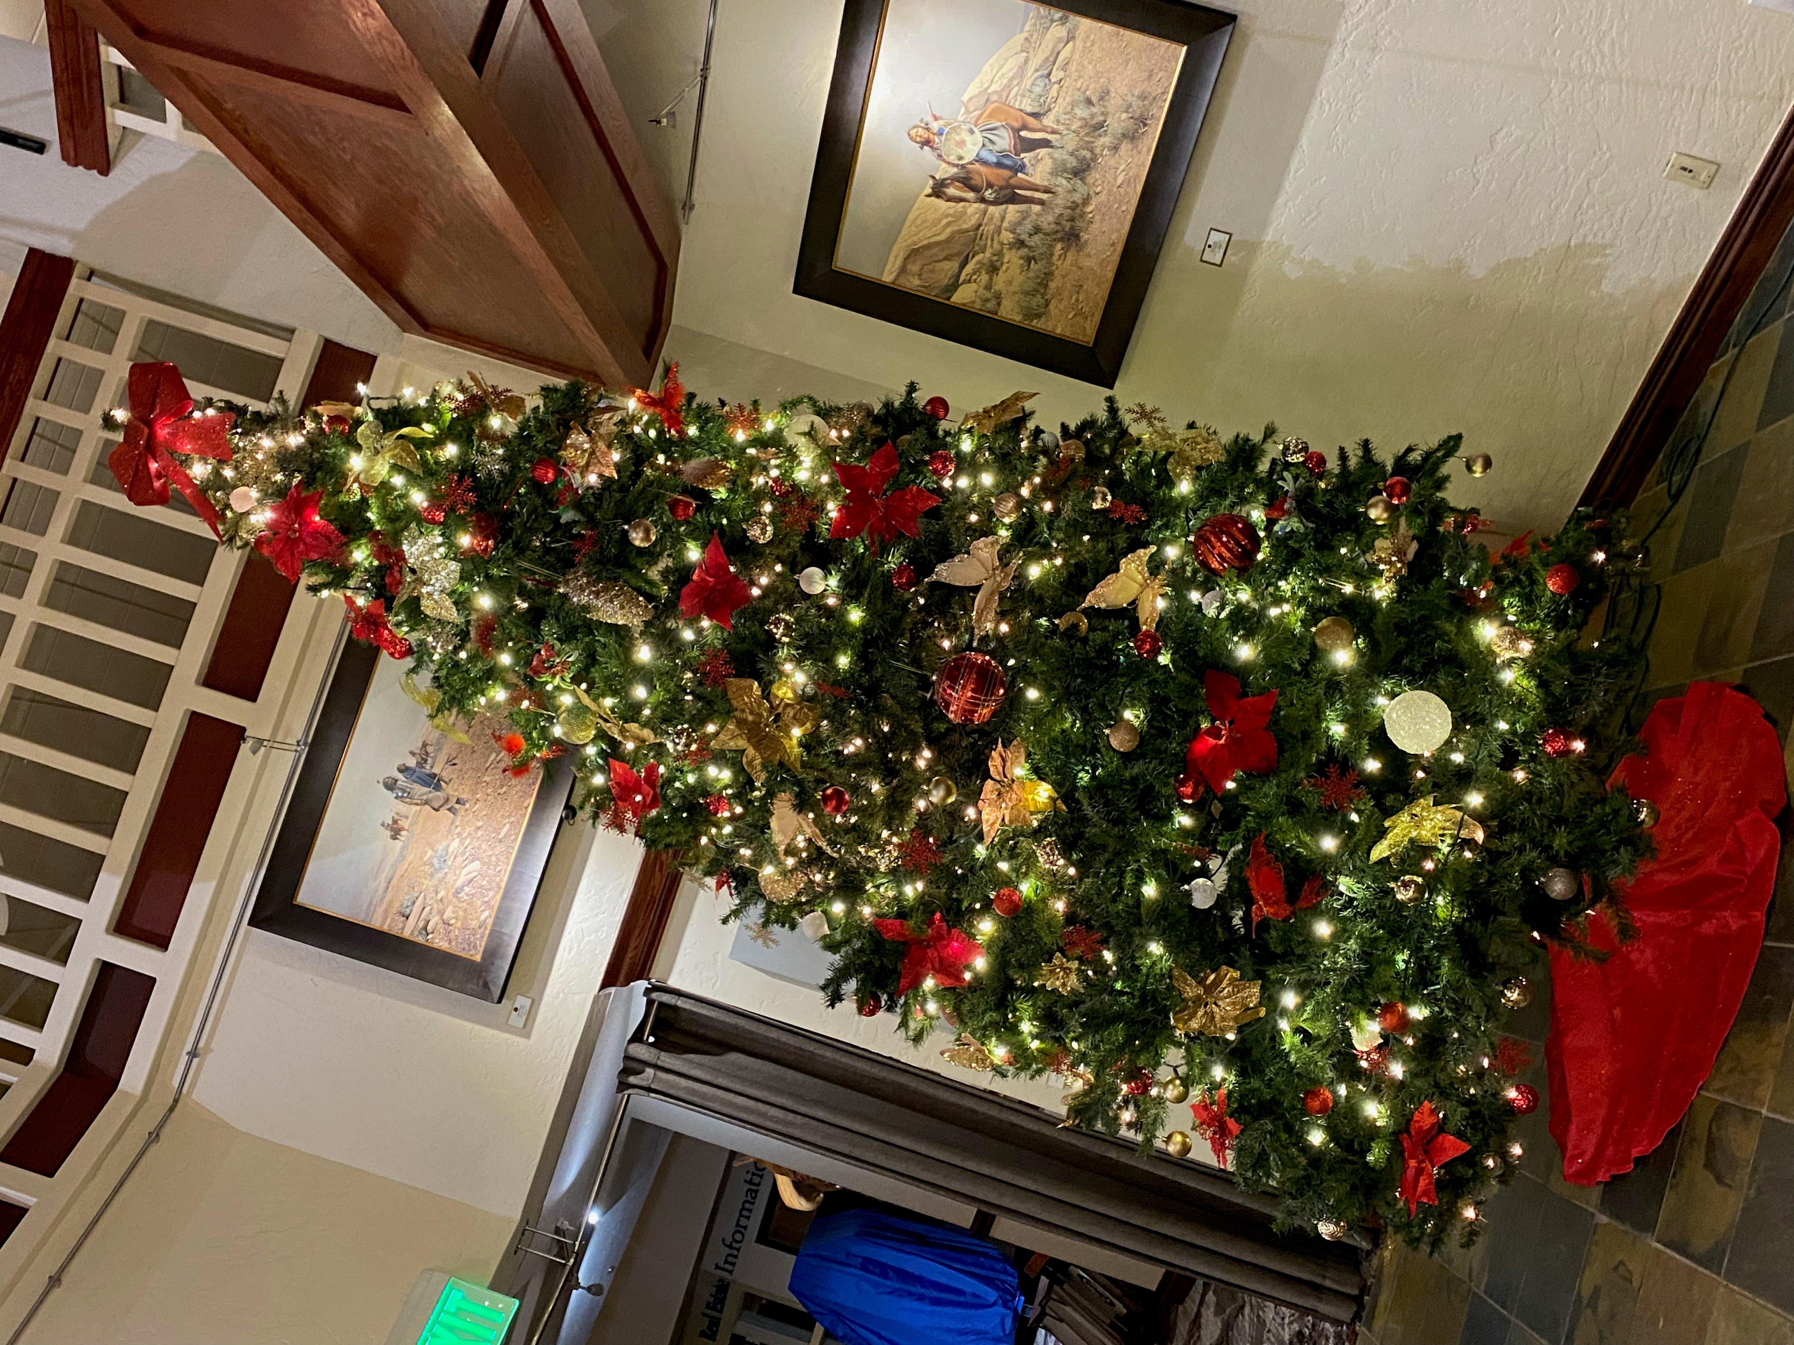

* Paul Jeppson – General Manager
* Liz Lyon – Front Office Manager
* Lavern Reid – Owner Liaison & Admin
* Lubos Bucko – Director Of F&B
* Sammy Shipman – Executive Chef
* Jody VanArsdale – Director Of Sales
* Kathy Roseberry-Duffy Director of HR
* Sam Labrum – Executive Housekeeper
* Mike Whitney – Chief Engineer
* Parvati Ramchandani – Concierge

VILAR PERFORMING ART SCHEDULE

December 20th

Charles Dickens’s A Christmas Carol

December 21st

Christmas with the 5 Browns

December 27th

Rhythmic Circus Holiday Shuffle

December 28th

Josh Turner

December 29th

The Doo Wop Project – Holiday in Harmony

December 30th

Just Willman- Magic for Humans in Person

December 1st

Mountain Mangart- Story of the 10th Mountain Division

December 3rd-4th

Warren Miller’s Winter

December 10th – 12th

The Nutcracker presented by Friends of Vail Dance

December 16th

Stars-DSQ Electric

December 17th

Dallas String Quartet’s Electronic Christmas

December 18th

Lacuna: Tom Hamilton & Holly Bowling

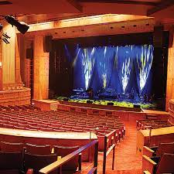

Meet Paul Jeppson our new General Manager. Paul is a 30 year veteran of the Hospitality industry and is joining us from Bozeman, Montana. He has worked for Vail Resorts managing Vail/Beaver Creek Resort properties and then Keystone Lodging for 18 years, subsequently he joined Delaware North managing the concession in Yosemite National Park for 3 years, and then the East Coast division including a concession in Shenandoah National Park as well as Sea Crest Beach Resort in Falmouth, MA, the new Westin Buffalo for another 3 years. Following the East Coast Paul took on the Rocky Mountain division with a concession in Yellowstone National Park as well as hotels in West Yellowstone and Whitefish, Montana. Now it was time to circle back to where it all started in Beaver Creek at the Beaver Creek Lodge. Paul and his wife Terri and their dog Kona reside in Avon. They have daughters in Denver. Colorado and Pacific City Oregon. Everyone is excited to be back where their daughters grew up and learned to ski.

UNCOVER A NEW STORY

MEET OUR NEW GENERAL MANAGER

We are excited to show off our brand new elevators which have been replaced from top to bottom. Urban Elevator just finished the last Guest elevator this past week and we have passed inspection by the Elevator Inspector, both residential are in full service. The service elevator was also replaced this summer and works so much better than the old clumber.

STAY INSPIRED

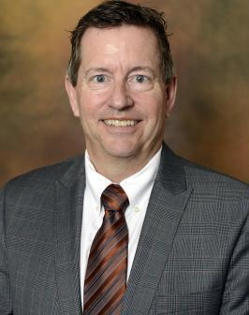

Meet Liz Lyon, our new Front Office Manager. Liz is a native of Colorado and has been in the hospitality industry for 14 years. She has worked in hotels all over the west including Flagstaff, AZ. Yellowstone National Park, Downtown Denver and many more. Liz has a degree in Anthropology which she finds helpful in daily life of interacting with different people. She loves hiking, camping, road trips with her dog Chaco is always with her. Liz is excited to see the winter in Beaver Creek and looks forward to working with both owners and guests of Beaver Creek Lodge.

UNCOVER NEW STORY





Meet Lavern Reid, our new Owner Liaison and Administrative Assistant. Lavern and moved here from Jamaica 5 years ago. She has worked for Xerox Corporation for over 15 years as an Accounts Payable Analyst. Since migrating to the USA she has worked in Sales for various retail companies and the hospitality industry. She currently reside in Avon with her husband John, her son Shawn and dog Liddy. She enjoys the outdoors and is becoming a snowboarding pro. Lavern will be a great addition to our team.